

**Continuing**

**Education**

**Program**

**Center for Computing and Information Technology**

**Faculty of Technic University of Indonesia**

**PROJECT ON**

**“Jobfield Recruitment”**

**Group : 8**

**Mutia Ayu Dianita**

**Muhamad Hudya Ramadhana**

**­­**

**Faculty : Bayu Citra Nur Aulia S.T, M.TI**

**Class :3 SC 1**

Faculty of Engineering University of Indonesia

Depok 16424

2016

**PROJECT ON**

*Jobfield Recruitment*

Developed By

*Name : Muhamad Hudya Ramadhana*

*Mutia Ayu Dianita*

NIIT

**JOBFIELD RECRUITMENT**

Batch Code : 3 SC 1

Start Date : September 7 , 2016

End Date : September 29, 2016

Name Of The Coordinator : Bayu Citra Nur Aulia S.T,M.TI

Name Of Developer : Muhamad Hudya Ramadhana

Mutia Ayu Dianita

Date Of Submission : September 30, 2016

NIIT

**CERTIFICATE**

This is to certify that this report, titled Jobfield Recruitment embodies the original work done by ***Muhamad Hudya Ramadhana and Mutia Ayu Dianita*** in partial fulfillment of their course requirement at NIIT.

Coordinator:

*Bayu Citra Nur Aulia S.T,M.TI*

**ACKNOWLEDGEMENT**

We have benefited a lot from the feedback and suggestions given to us by Mrs. Bayu Citra Nur Aulia S.T, M.TI and other faculty members. The Project presentation opportunity we have with CCIT-FTUI is a greatchance for learning and professional development. Therefore, we consider ourselves very lucky as we are provided with an opportunity to be a part of it. We are also grateful for having a change to meet so many wonderful people and professionals who led us through this project period.

Bearing in mind, we would like to express our deepest gratitude and special thanks to Bayu Citra Nur Aulia S.T,M.TIof CCIT-FTUI faculty who is spite of being extraordinarily busy with her duties, took time out to hear, guide and keep us on the correct path and allowing us to carry out our project until completion.

Our Project assignment won’t be as good as it is now without any help, feedback and suggestion that were given to us by our friends within the campus. So, we would also like to say thank you to all of them. We will strive to use gained skills and knowledge in the best possible way, and we will continue to work on the improvements, in order to attain desired career objective.

**SYSTEM ANALYSIS**

**System Summary:**

Jobfield Recruitment is a web that helps a company to recruit programmers. The programmers can apply job to the company by this web. Also the admin can see the data of the appliers so they can choose the programmer that suits the job.

There are 2 main pages in this web, for applier and for admin. When the main page for applier shown, in the display there are several things that the appliers can do, they can see the news in main page and click the news details and fill the form, after that appliers can see the data in card page. User also can send the message for admin by fill the message form in contact us page.

The main page for admin display sidebar for admin menu, admin can add and see the list of appliers data, add and see the list of news data, and see the list of messages from appliers.

**HTML INTERFACE**

*Index.html*

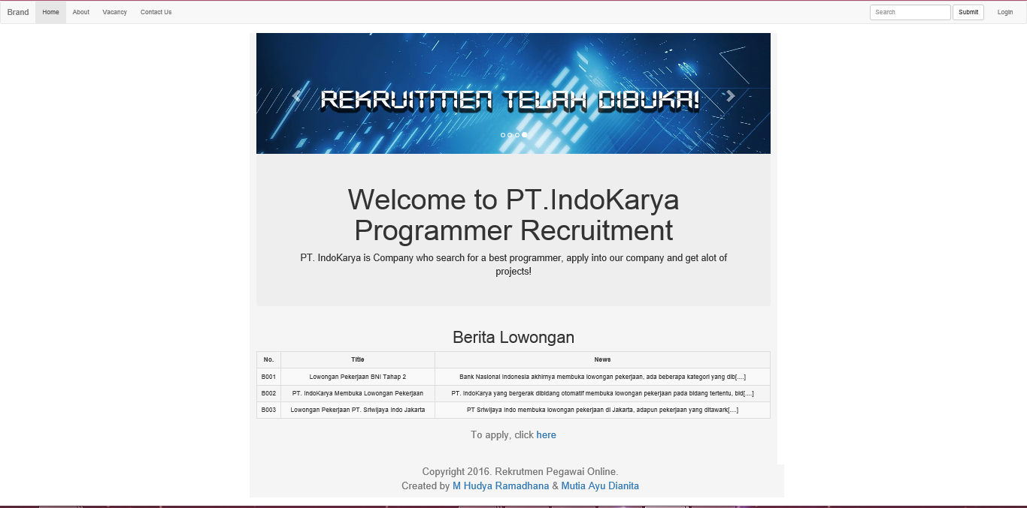

*Vacancy.html*

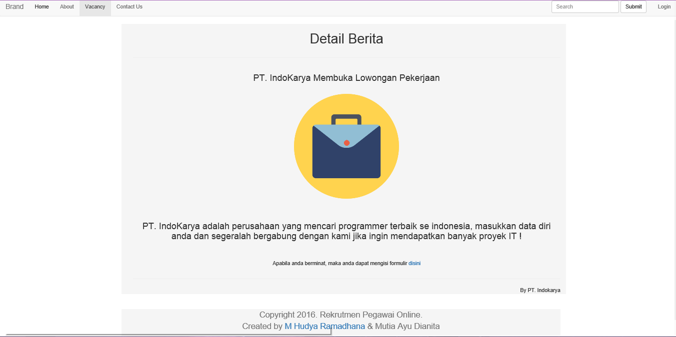

**HTML INTERFACE**

*Card.html*

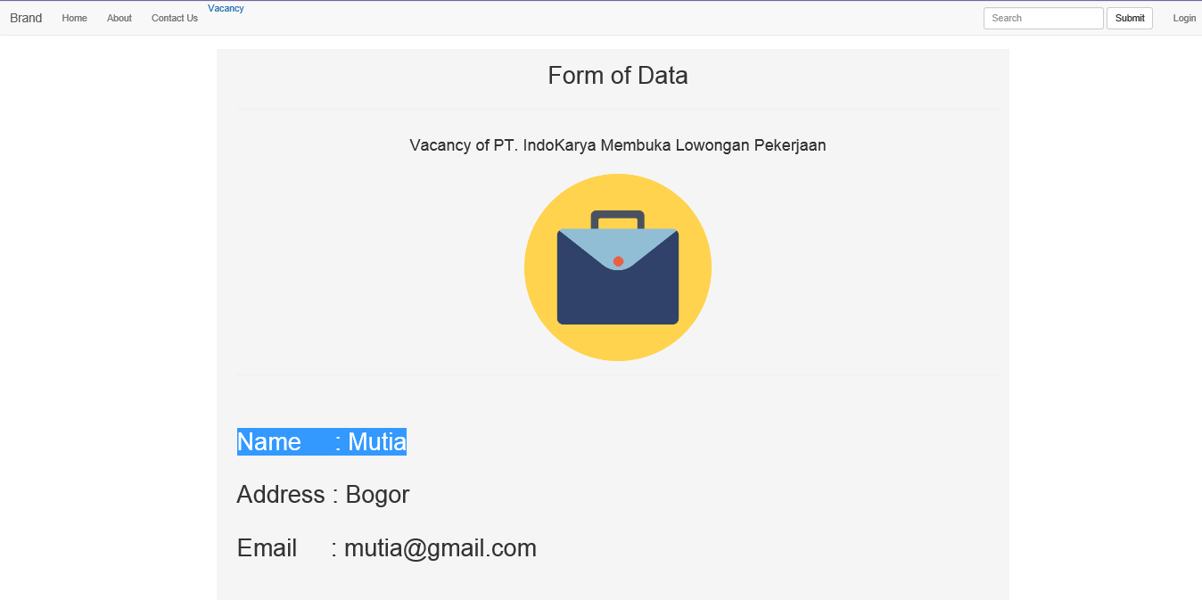

*Form.html*

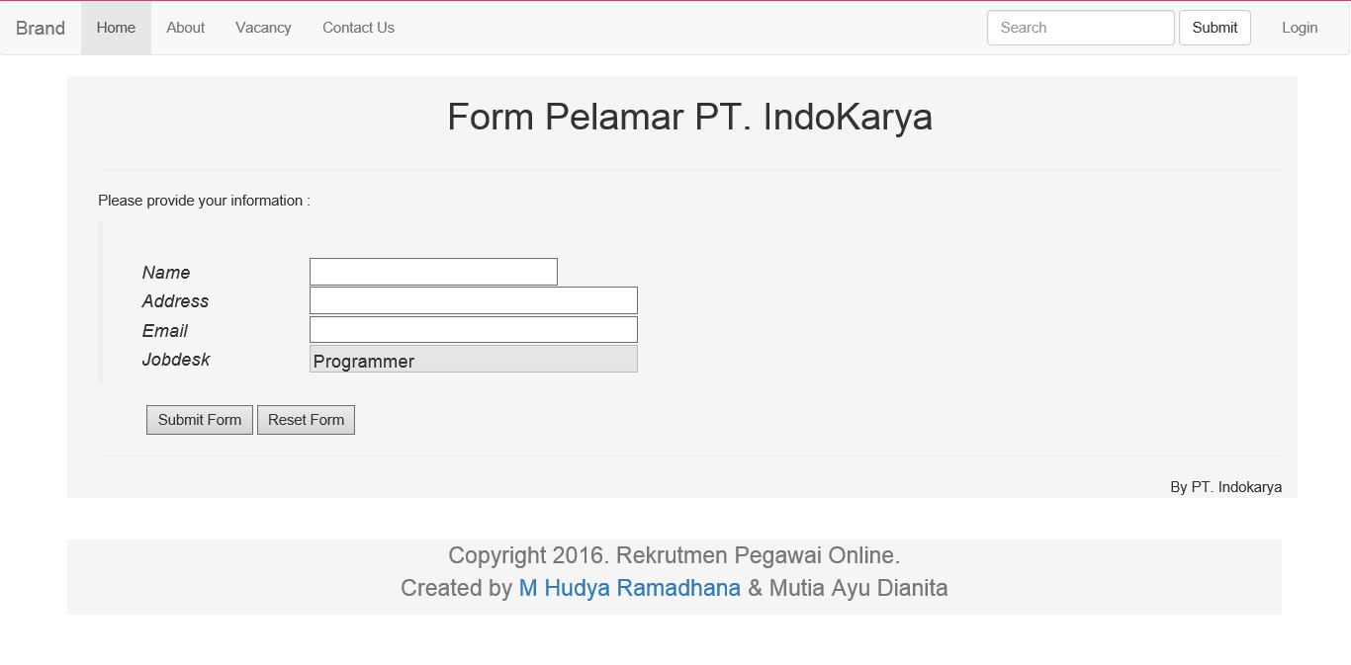

**HTML INTERFACE**

*Contactus.html*

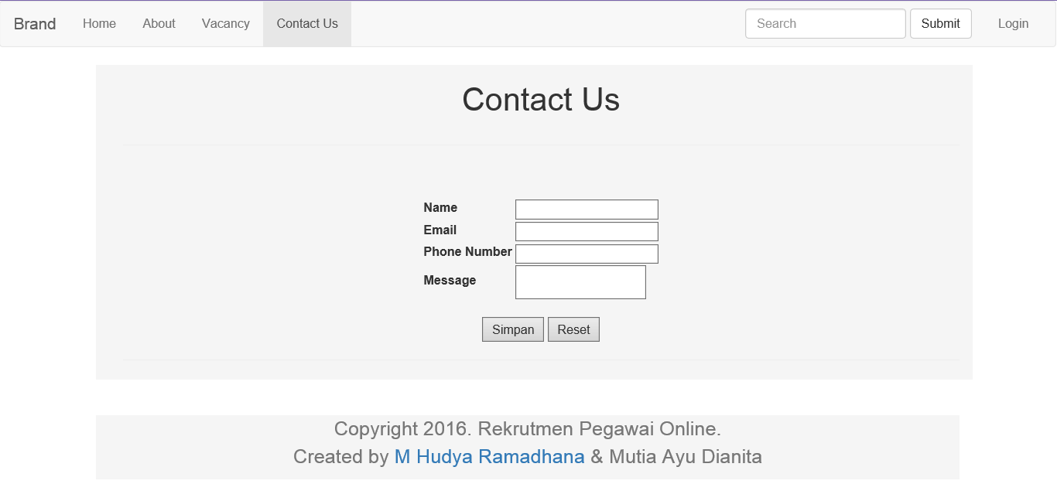

*Admin.html*

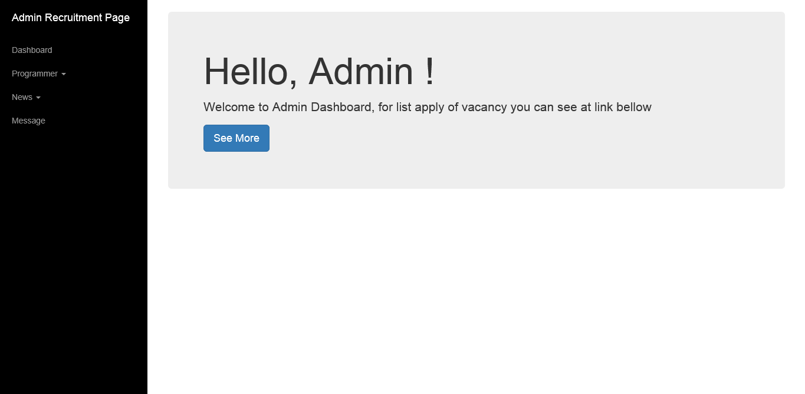

**HTML INTERFACE**

*Listapply.html*

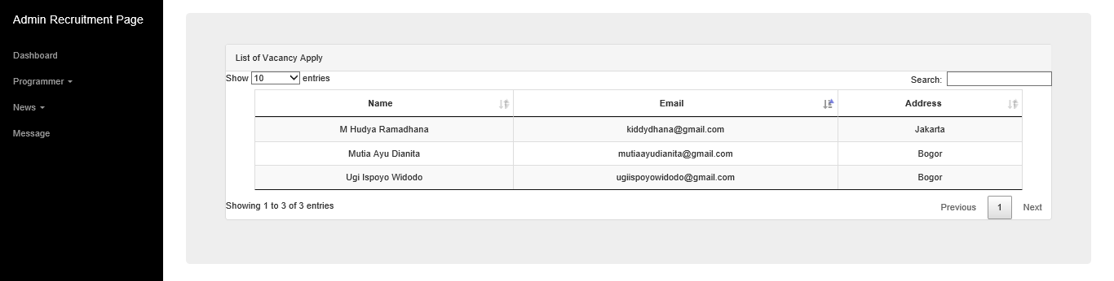

*Addpegawai.html*

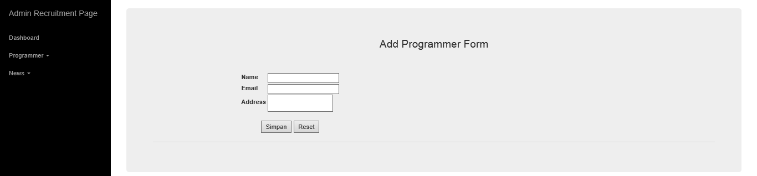

*Addnews.html*

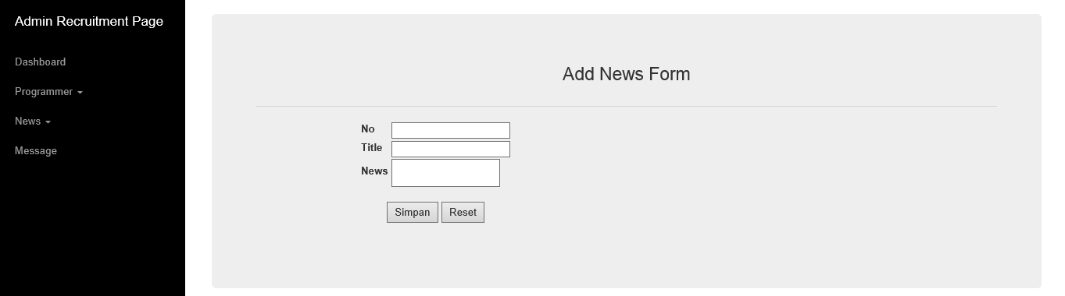

**HTML INTERFACE**

*News.html*

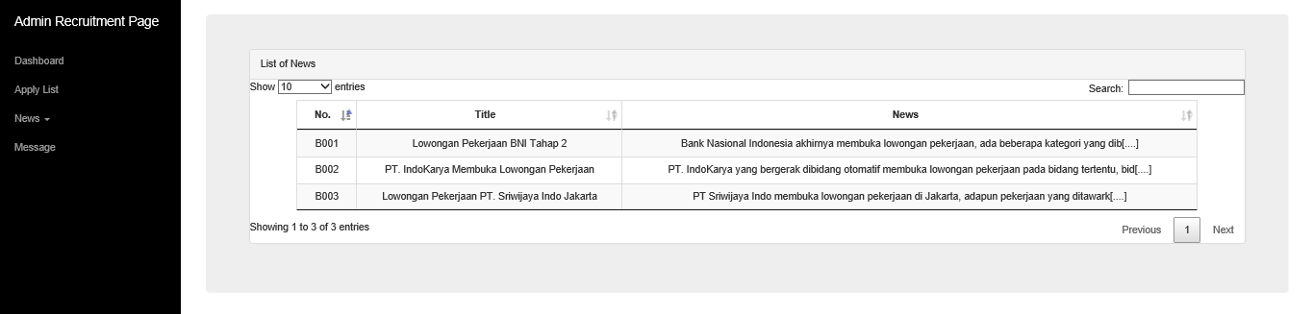

*Message.html*

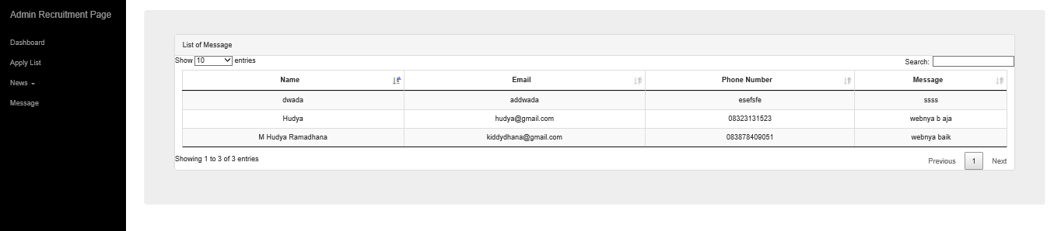

**CONFIGURATION**

**Hardware: Asus X450C, Intel(R) Core(TM) i3** **8.00 GB (RAM)**

**Operating System: Microsoft Windows 8.0 Pro, 64-bit Operating System**

**Software: Oxygen XML Editor 18.0**

**Internet Explorer**

**Project File Outline**

**HTML**

|  |  |  |
| --- | --- | --- |
| **S. No** | **File Name** | **Remarks** |
| 1 | index.html | This is the first page of the website, contains the code for displaying main page and news for appliers |
| 2 | vacancy.html | Contain the code for displaying details of news |
| 3 | form.html | Contain the code for inserting apply form for appliers |
| 4 | card.html | Contain the code for displaying details of appliers data |
| 5 | contactus.html | Contain the code for inserting message form |
| 6 | admin.html | Contain the code for displaying main page of admin |
| 7 | listapply.html | Contain the code for displaying list of appliers for admin |
| 8 | addpegawai.html | Contain the code for inserting form of news for admin |
| 9 | addnews.html | Contain the code for insering form of news for admin |
| 10 | news.html | Contain the code for displaying table of news for admin |
| 11 | message.html | Contain the code for displaying table of messages from user for admin |

**XML**

|  |  |  |
| --- | --- | --- |
| **S. No** | **File Name** | **Remarks** |
| 1 | berita.xml | Contains the data of news |
| 2 | pelamar.xml | Contains the data of appliers |
| 3 | pesan.xml | Contains the data of messages from user |

**Project File Outline**

**XSD**

|  |  |  |
| --- | --- | --- |
| **S. No** | **File Name** | **Remarks** |
| 1 | berita.xsd | The XML Schema Document for XML Document, berita.xml |
| 2 | pelamar.xsd | The XML Schema Document for XML Document, pelamar.xml |
| 3 | pesan.xsd | The XML Schema Document for XML Document, pesan.xml |

**CSS**

|  |  |  |
| --- | --- | --- |
| **S. No** | **File Name** | **Remarks** |
| 1 | bootstrap.css | This CSS is used to style the user interface pages |
| 2 | bootstrap.min.css | This CSS is used to style admin interface pages |
| 3 | simple-sidebar.css | This CSS is used to style sidebar for admin pages |
| 4 | jquery.dataTables.css | This CSS is used to make jquery datatable in news.html, listapply.html, and message.html |
| 5 | dataTables.bootstrap.css | This CSS is used to style datatable in news.html, listapply.html, and message.html |